**Assignment -1**

Python Programming

|  |  |
| --- | --- |
| Assignment Date | 19 September 2022 |
| Student Name | Vaishak S |
| Student Roll Number | 710619106307 |
| Maximum Marks | 2 Marks |

**Question-1:**

Develop a sample homepage with html , CSS which should include banner , image & description about yourself and contact form

|  |
| --- |
| **Solution:** |
|  |
|  |
|  |
|  |
|  | <html>  <head>  <meta name="viewport" content="width=device-width, initial-scale=1.0">  <title>responsive html homepage</title>  <link rel="stylesheet" href="responsivestyle.css">  </head>  <body>  <div class="name">  <h2>Vaishak</h2>  </div>  <div class="no1">  <h2>Contact Details</h2>  <p><b>E-mail: </b>issacsenthil2002@gmail.com</p>  <p><b>Phone: </b>6379118352</p>  </div>  <div class="no2">  <h2>Area Of Intrest</h2>  <ul>  <li>Cloud app Development</li>  <li>Web Development</li>  </ul>  <br>  </div>  <div class="no3">  <h2>Soft Skills</h2>  <ul>  <li>Good Communicator</li>  <li>Creative</li>  </ul><br><br>  </div>  <div class="no4">  <h2>Hard Skills</h2>  <ul>  <li>Python</li>  <li>Java</li>  <li>SQL</li>  <li>HTML</li>  </ul>  </div>  <div class="no5">  <h2>Languages Known</h2>  <ul>  <li>English</li>  <li>Tamil</li>  </ul>  </div>  <div class="objective">  <h2>Objective</h2><br>  <p>To work in an environment which encourages me to succeed and grow professionally where I can utilize my  skills and Knowledge appropriately.</p>  </div>  <div class="education">  <h2>Education</h2><br>  <p>  <b>CSI College of Engineering</b>  2019-2023  B.E Electronic And Communication Engineering  8.99 CGPA  </div>  <div class="project">  <h2>Project</h2><br>  <b>smart fashion recommendor application</b>  <p>This project aims at building a web app that automatically estimate the continuouslyenhanceusertrustinthewebsite,  improve page visits and dwelltime, and most importantly ,increase grossmerch and is evalue, it is crucial tounder  stand and capture the important information hidden in the data, which has a great impactonuser choice.  </p>  </div>  </body>  </html> |
|  |
|  |  |
|  |  |
|  |  |

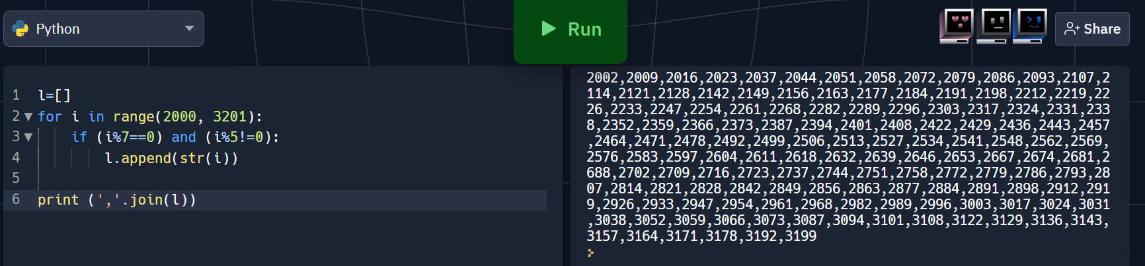

**Question-2:**

With a given integral number n, write a program to generate a dictionary that contains (i, i*i) such that is an integral number between 1 and n (both included). and then the program should print the dictionary.

Suppose the following input is supplied to the program:

8

Then, the output should be:

{1: 1, 2: 4, 3: 9, 4: 16, 5: 25, 6: 36, 7: 49, 8: 64}

|  |
| --- |
| **Solution:** |
|  | n=int(input()) |
|  | d=dict() |
|  | for i in range(1,n+1): |
|  | d[i]=i*i |
|  |  |
|  | print d |
|  | #----------------------------------------# |
|  | #----------------------------------------# |

